**What factors influence the abundance of photosynthetic proteins in leaves?**

**t**emperature and light environment determine abundance of leaf photosynthetic proteins in wild Eucalypts; a **quantitative, continental-scale ecological proteomics study**

Research questions:

1. How does photosynthetic protein abundance in leaves follow biogeographic gradients (temp, rainfall, soil chemistry)?

* Are proteins involved in light harvesting or CO2 assimilation more responsive to environmental conditions?
* Hypotheses (re: Hikosaka & Terashima 1995):
  + Rainfall & light environment:
    - Photosystem complex proteins will be most abundant where leaf-level irradiance is lowest, and photosynthesis is light-limited
      * Similarly, Photosystem complex proteins will be most abundant at higher rainfall sites, due to greater vegetation density and competition for light
    - Calvin cycle enzymes and electron transport proteins will be more abundant in high light conditions, as they determine the rate of light-saturated photosynthesis (Farquar 1980) “The two major biochemical processes thought to limit photosynthesis are the carboxylation of ribulose-1,5-bisphosphate (RuBP) and electron transport photochemistry for the regeneration of RuBP in the Calvin cycle (Farquhar et al. 1980).”- Lin et al 2011 ‘Temperature responses of leaf net photosynthesis: the role of component processes’
    - Calvin cycle proteins will be most abundant at low rainfall, so as to effect greater Ci drawdown at lower time-averaged Gs.
  + Temperature:
    - Calvin cycle enzymes and electron transport proteins will be more abundant at lower temperatures, to counteract slow enzymatic reaction rates
      * Alternative hypothesis is that leaf temperature is different enough from ambient temperature due to all the energy and gas fluxes associated with photosynthesis that there will be no effect here
    - Photosystem complex protein abundance will not be affected by temperature as rate of photon capture is not meaningfully affected by leaf temperature
* Would be ideal to answer these q’s using avg molar ratios of photosystem proteins / Calvin cycle proteins plotted over gradients, but we need the QCONCAT standards

1. Is there an influence of genetic lineage on the response of photosynthetic protein abundance to environmental conditions?
2. How do abundances of photosynthetic proteins change with leaf age?

* Hypotheses:
  + Abundance of light harvesting proteins increases with age to counter reduced light interception
    - Is there any effect of leaf age independent of increased shading? Can’t answer this directly but worth discussing
  + Calvin cycle & electron transport proteins remain constant or are proportionally reduced as leaves age
  + Nitrogen is progressively allocated to recalcitrant structural and defensive protein throughout leaf lifespan, so older leaves contain proportionally less photosynthetic protein
    - Re: Onoda et al. 2003 “Allocation of nitrogen to cell walls decreases photosynthetic nitrogen-use efficiency”
    - But see Hikosaka & Shigeno 2009 “nitrogen allocation to cell walls does not explain the variation in PNUE”
    - Have not quantified structural / cell-wall associated proteins here

1. To what extent is variation in photosynthetic protein abundance driven by different environmental factors?

**Biogeography**

Rainfall & light environment:

* Photosystem complex proteins will be most abundant where leaf-level irradiance is lowest / canopy is most closed, and photosynthesis is light-limited
  + Similarly, Photosystem complex proteins will be most abundant at higher rainfall sites, **due to greater vegetation density and competition for light (but we can’t show any clear relationship between gap fraction and precip!)**
* Calvin cycle enzymes and electron transport proteins will be more abundant in high light conditions, as they determine the rate of light-saturated photosynthesis (Farquar 1980)
  + Alternatively etransport proteins might scale with photosystem abundance
* Calvin cycle proteins will be most abundant at low rainfall, so as to effect greater Ci drawdown at lower time-averaged Gs.

*Panels of protein abundance vs gap, irradiance, leaf-level irradiance, prec*

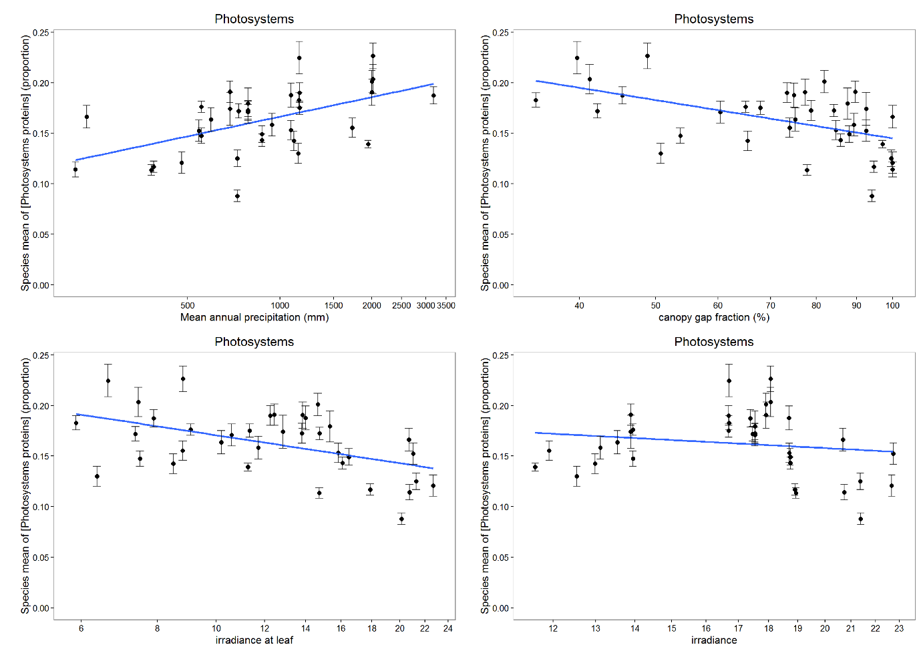

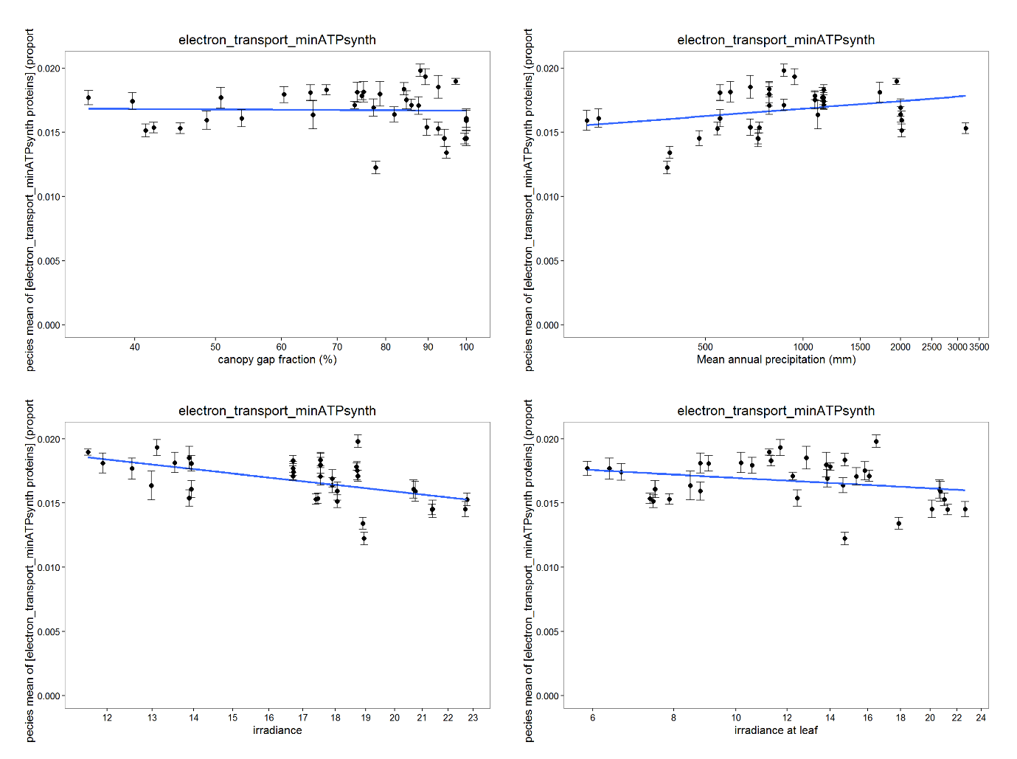

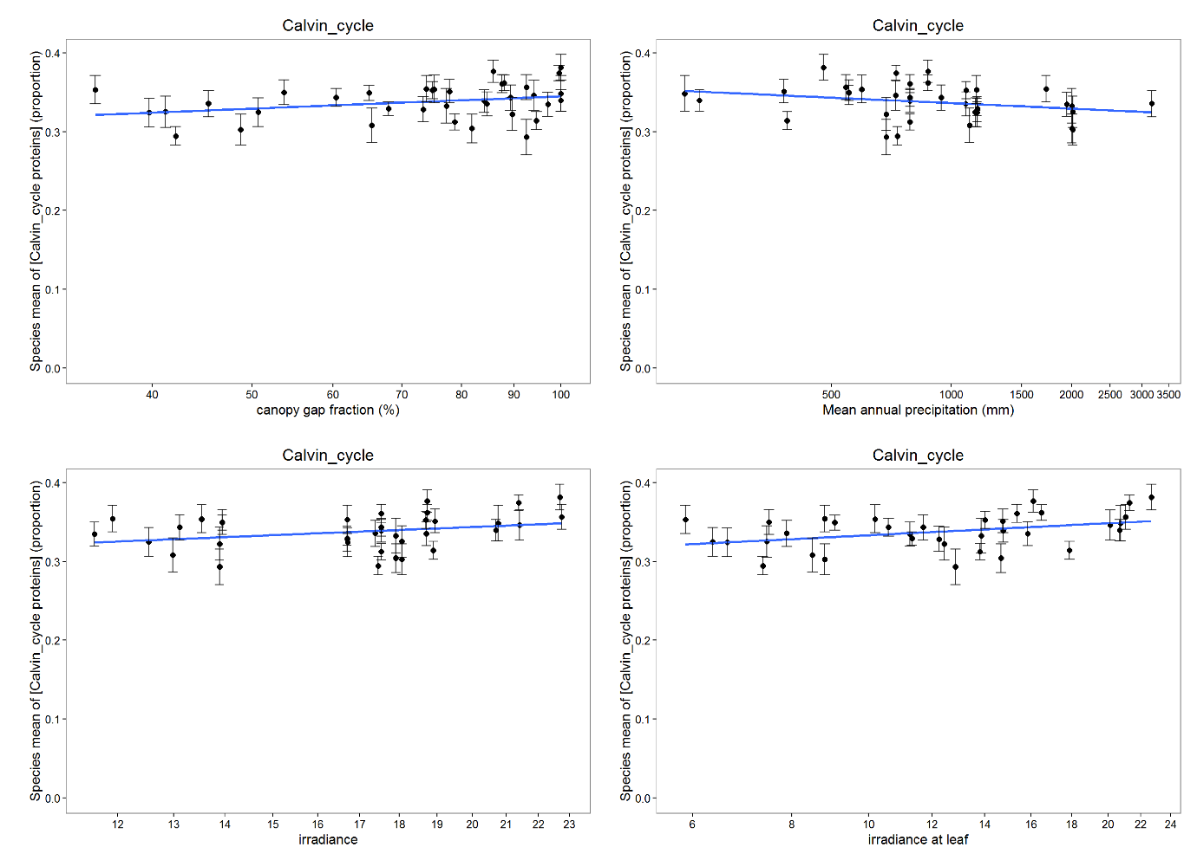

*Co-ordinations of env variables; etransport proteins vs photosystem proteins*

Temperature:

* Calvin cycle enzymes and electron transport proteins will be more abundant at lower temperatures, to counteract slow enzymatic reaction rates
  + Alternative hypothesis is that leaf temperature is different enough from ambient temperature due to all the energy and gas fluxes associated with photosynthesis that there will be no effect here
* Photosystem complex protein abundance will not be affected by temperature as rate of photon capture is not meaningfully affected by leaf temperature

